Design your Program
Write a program that will read in two integers and then output their sum, difference, and product.
---------------- requirement for Assignment: Input & Assignment Statement -----------

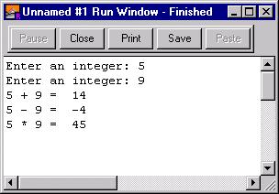Input
num1: int
num2:int

Process
sum = num1 + num2
difference = num1 - num2
product = num1 * num2

Output
sum
difference
product
---------------- end requirement for Assignment: Input & Assignment Statement -------

Algorithm
An algorithm is a step by step solution in a generic language (like pseudocode but less code like). An algorithmic solution can be translated into any programming language; it's language independent.
---------------- beginning of algorithm ------------------
Program in Turing

var num1:int
var num2:int
var sum:int
var difference:int
var product:int

%input
put "Enter an integer: "..
get num1
put "Enter an integer: "..
get num2

%process
sum:=num1 + num2
difference:=num1 - num2
product:=num1 * num2

%output
put num1," + ", num2," = ", sum
put num1," - ", num2," = ", difference
put num1," * ", num2," = ", product

% get required input
prompt for num1
get num1
prompt for num2
get num2

% perform processes
sum = num1 + num2
difference = num1 - num2
product = num1 * num2

% produce output
display sum
display difference
display product
-------------------------- end of algorithm -------------------

